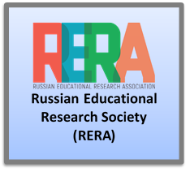
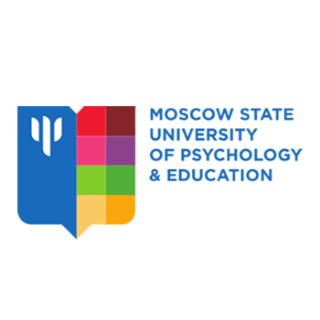

RUSSIAN EDUCATIONAL RESEARCH ASSOCIATION
PSYCHOLOGICAL INSTITUTE OF RUSSIAN ACADEMY OF EDUCATION
MOSCOW STATE UNIVERSITY OF PSYCHOLOGY & EDUCATION

INFORMATION LETTER
International conference
“Scientific school of Vasily Davydov: traditions & innovations”
September 22-24, 2020, Moscow
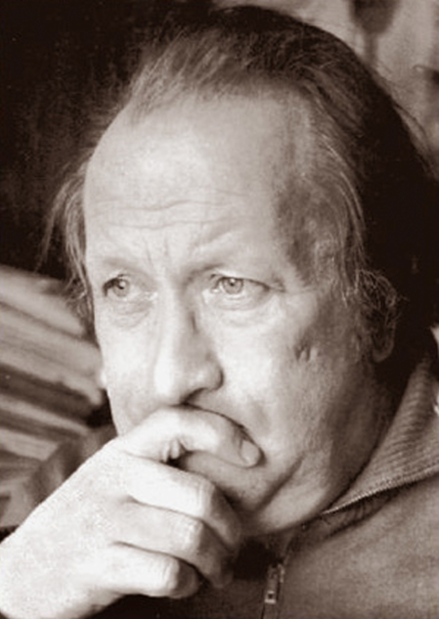

This year the conference is dedicated to the 90th anniversary of Vasily Davydov, an outstanding scientist, thinker, teacher and reformer of education, the founder of a new scientific school in psychology.

The event is aimed at discussing the contribution of Vasily Davydov in Russian and world science, understanding ways of solving the problems of learning and development in modern society.

The objectives of the conference include a broad discussion from the perspective of an activity-oriented approach to the development of the theory and practice of developing education in the 21st century, as well as formulation of urgent problems of modern didactics and approaches for designing a new school.

This will be the 3rd conference of the project “Modern didactics”.
Conference co-organizers:
Russian Educational Research Association (RERA)
Moscow State University of Psychology & Education (MSUPE)
Psychological Institute of the Russian Academy of Education

With participation of:
National research university “High School of Economics”
Moscow State Pedagogical University

Conference venue:
Moscow State University of Psychology & Education
(127051, Russian Federation, Moscow, Sretenka street, bld. 29)
Psychological Institute of Russian Academy of Education
(125009, Russian Federation, Moscow, Mokhovaya street, bld. 9/4)

Key conference subject fields:

“Consciousness and reasoning in thinking and activity: the approach of Vasily Davydov’s scientific school”

“Developing learning today: research & practice”

“Interrelation between preconceptions and scientific conceptions: education as a resource of development of thinking”

“Monitoring of educational results in the system of developing learning”

“Modern school in the framework of Vasily Davydov’s ideas: Problematization. Projecting. Educational effects assessment”

“Teacher’s training for developing education”

Forms of conference activities:

1. Plenary session / panel discussion

2. Thematic sessions

3. Special evening in memory of V. Davydov.

Personal:

participation with presentation (1); participation without presentation (as a listener) (2)

Distant: participation only with publication in the collection of abstracts (3)

Registration procedure:

Registration of participants is necessary through the official website of the conference:
http://www.davydov-conf.ru

The collection of abstracts of the International conference "Scientific school of Vasily Davydov: traditions and Innovations” is planned to be published.

To participate in the publication, it is necessary to submit abstracts on the email: davydov2020@mgppu.ru
The abstract requirements are formulated in the attachment.

Application deadline for participation with a presentation: April 20, 2020 (23:59 Moscow time)

Application deadline for participation as a listener: May 10, 2020 (23:59 Moscow time)

There is no organizing fee for participation in the conference.

All participants will receive the certificates of attending conference.

Official conference website: http://www.davydov-conf.ru
E-mail for abstracts: davydov2020@mgppu.ru

